Access Controls : The authorization Concepts for ABAP CDS

Introduction:
Authorization for reading data of CDS entity restricted using access control.
Motivation: Code push down of user authorizations.
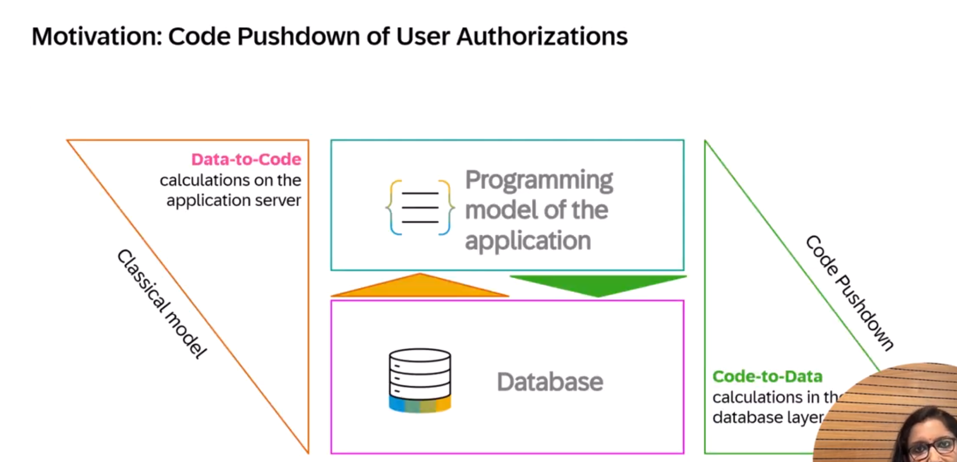
In traditional : calculation done in Application layer.
In code push down : calculation done in database layer.
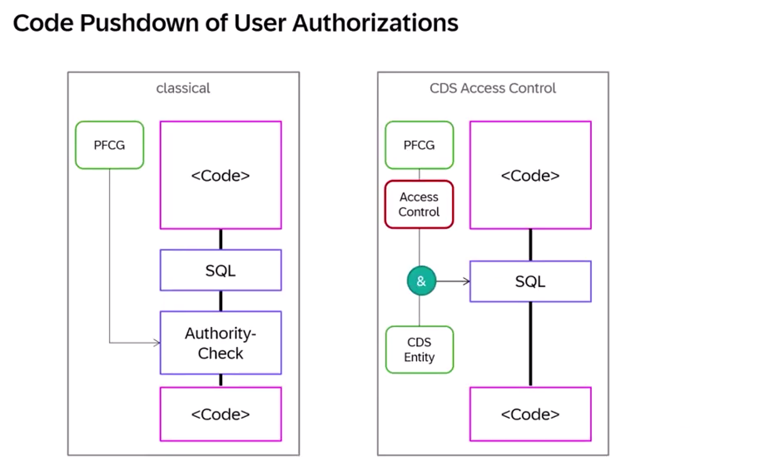
In cds access control is based on data control language (DCL), it will apply the restriction on data selection cds entity with abap sql.
For explicitly need to define the access control for each individual entity to protect the data.
CDS access control mainly includes –
- CDS role
- CDS access rules
- CDS access conditions
Access control is defined for CDS entity, and access conditions are evaluated on only the data that satisfies the conditions is being read out.
Access conditions based on literal values. Specifie the
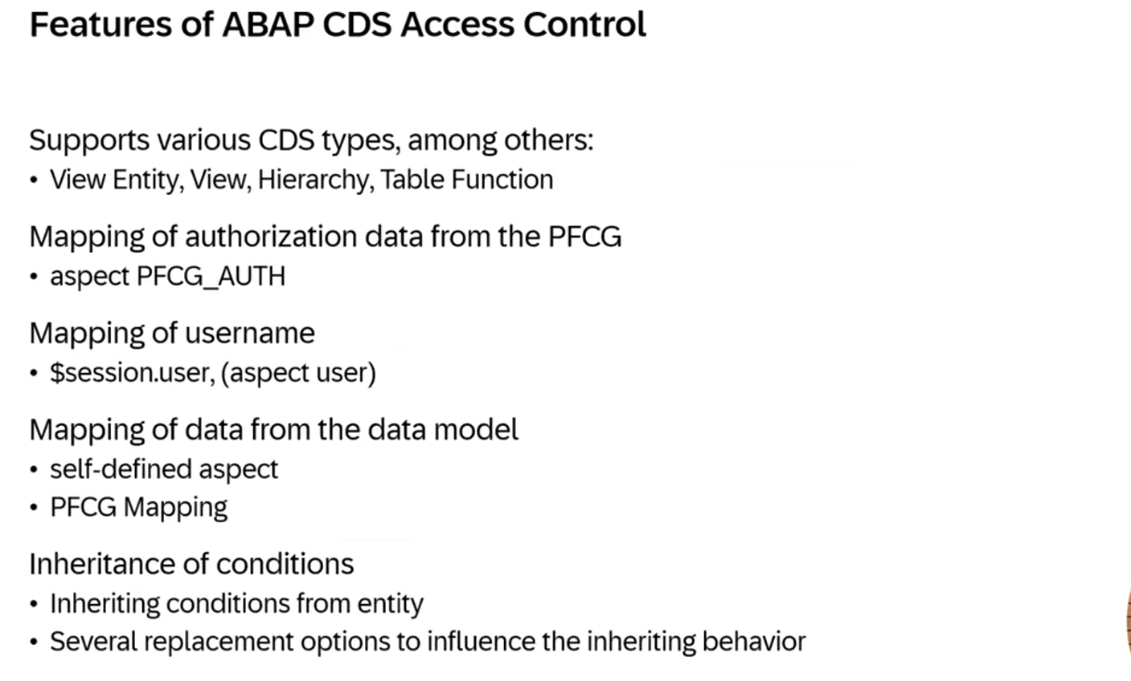
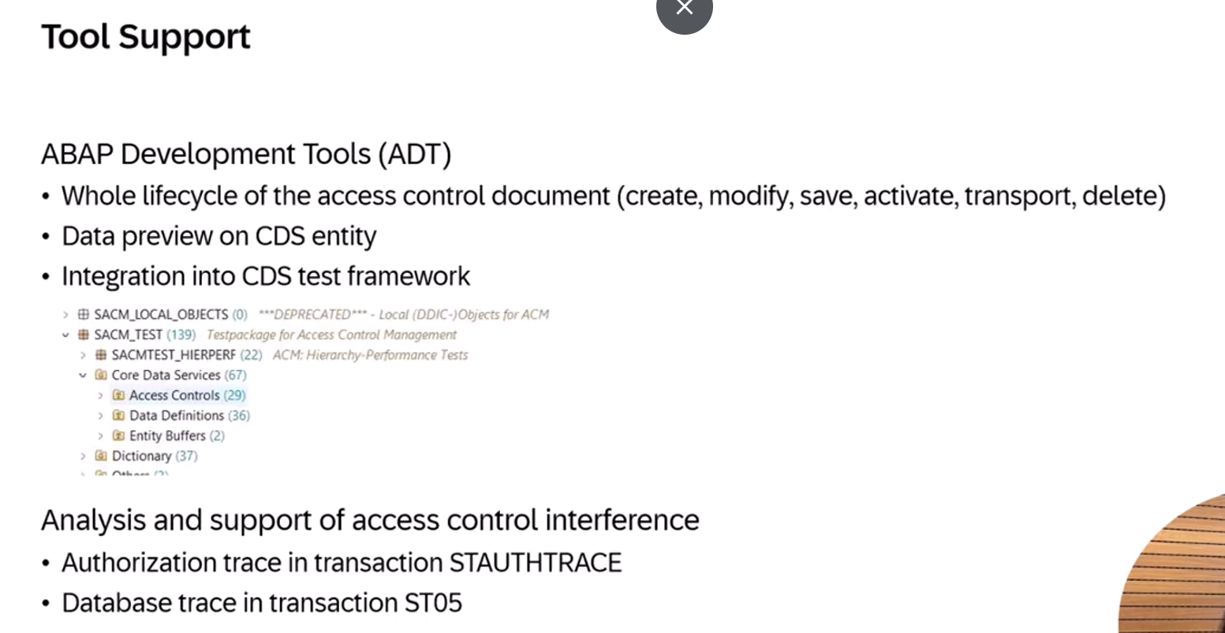

Demo
Flight demo data:
Two cds views: ZI_FLIGHT and ZC_FLIGHT
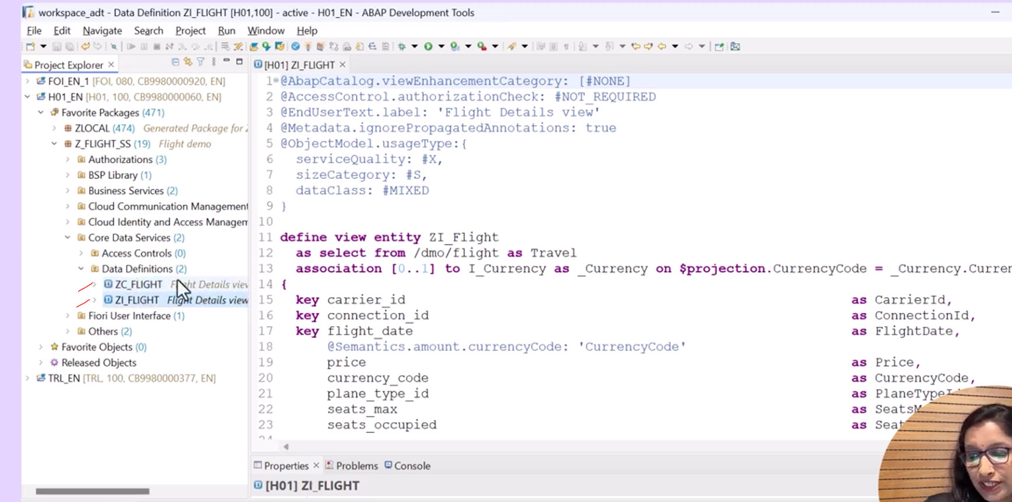
Data preview of ZI_FLIGHT:
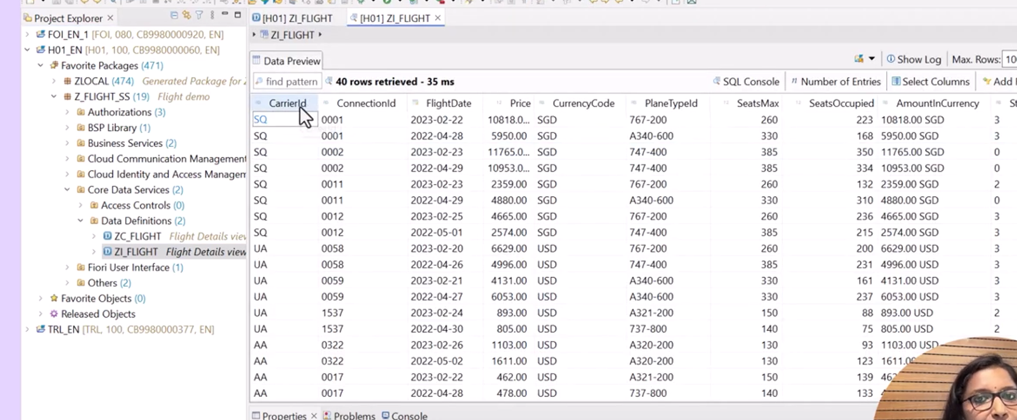
Annotations required for access control is :
@AccessControl.authorizationCheck : #NOT_REQUIRED : used to to control the data visibility to the user.
Values:
Bydefault value - #NOT_REQUIRED – means, not performing any action on user to visibility on data – full access.
#CHECK: - it will gives the syntax warning. If access control not associated with the view entity., if you created the access control it will perform else through the warning message.
#MANDATORY: access control should exist, if not then runtime error will occur.
#NOT_ALLOWED:if access control exist- it will ignore at runtime.
#PRIVILIGED_ONLY: it is the special value, this is valuated framework such as SADL.
In demo I will use #CHECK and activate.
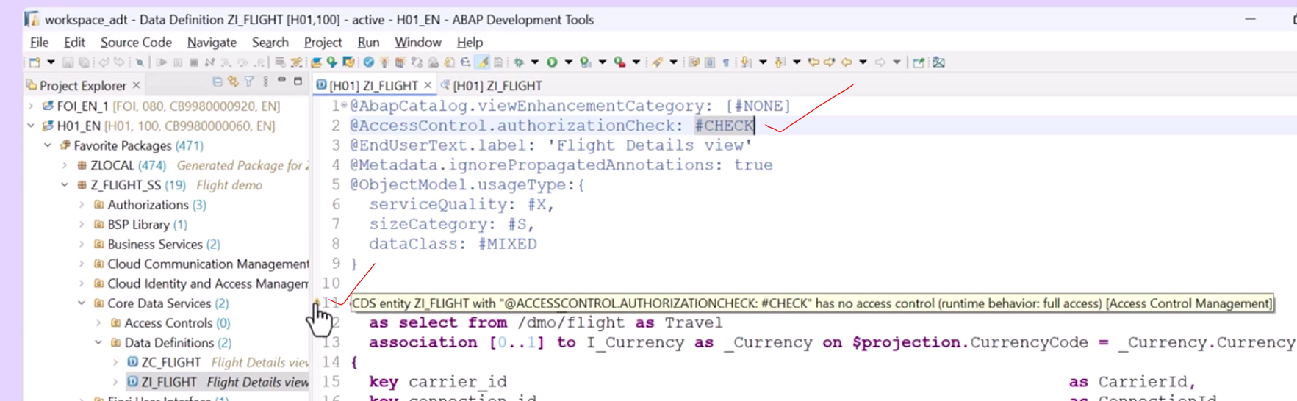
Throwing warning messages: #CHECK.

Access control on literal base
Create access control on ZI_FLIGHT right click on it Click on New access control.
- Name :ZI_FLIGHT_AC and description: Access control for flight details.
- Protected entity: ZI_FLIGHT
- Save under TR.
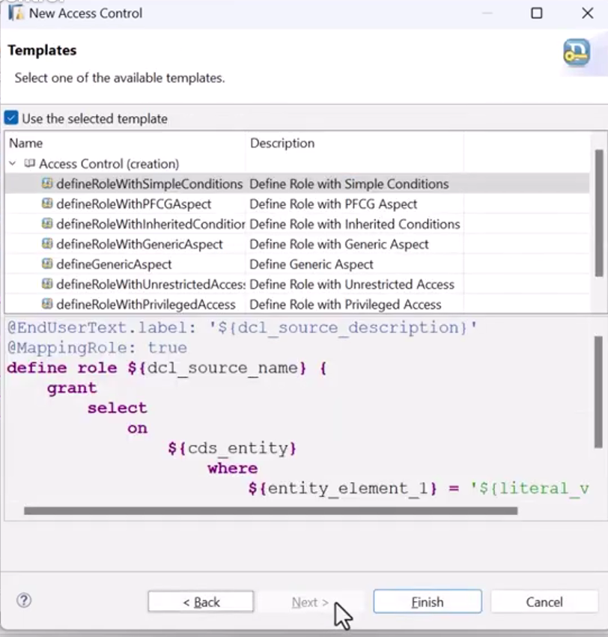
Take template as role with simple conditions:
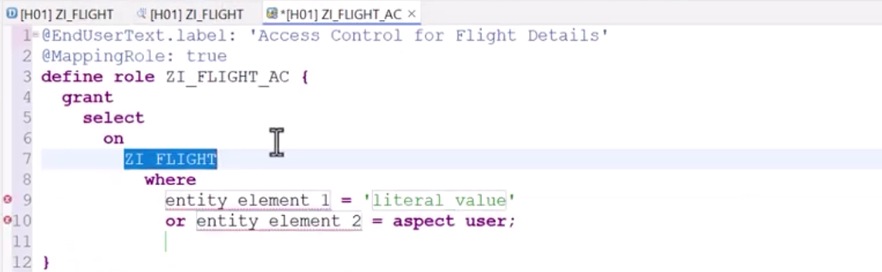
@MappingRole: true
CDS view name should specify on grant select on.
Provide where conditions as carrierid = ‘SQ’
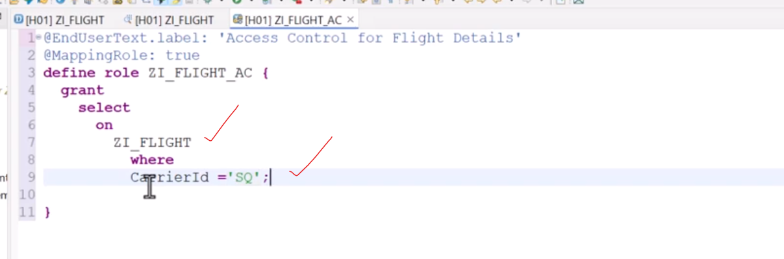
Now refresh the data preview after access control creation.- ZI_FLIGHT
Now you can see the data only for SQ only—means access control has been performed.
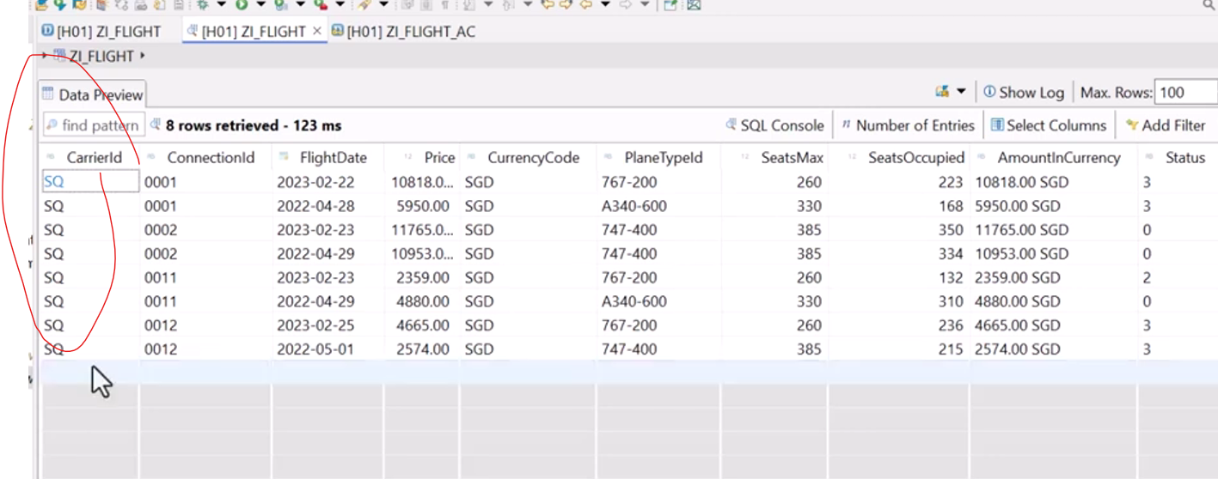

Access control on Authorization object- classic based on PFCG condition:
Create the authorization fields and bundle with authorization object.
Already I created the authorization object and authorization fields.
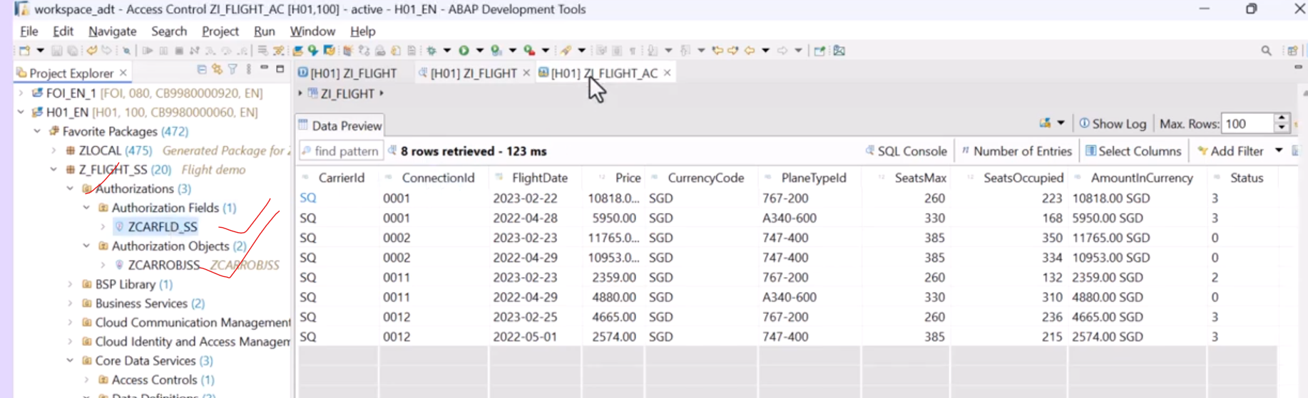
On premise: create the authorization object and authorization fields default authorization maintain for the user.
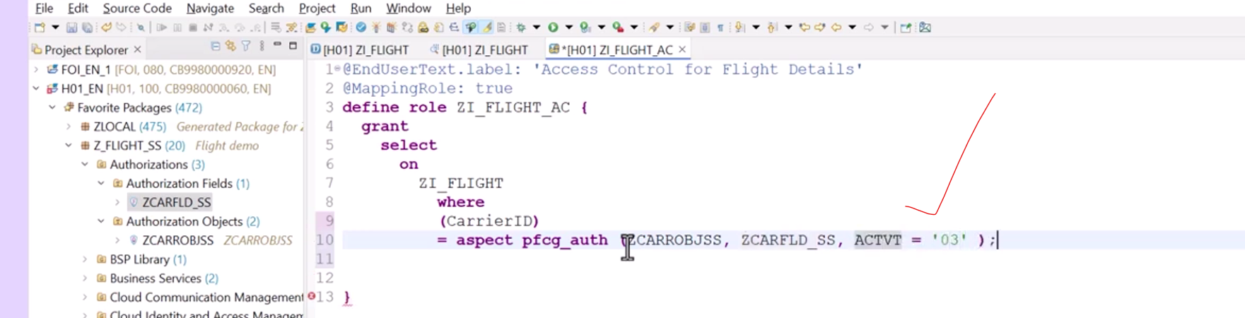
For my userid I set the value of carrier id is ‘AA’- so when I execute the data- it will display for AA for specific user id.
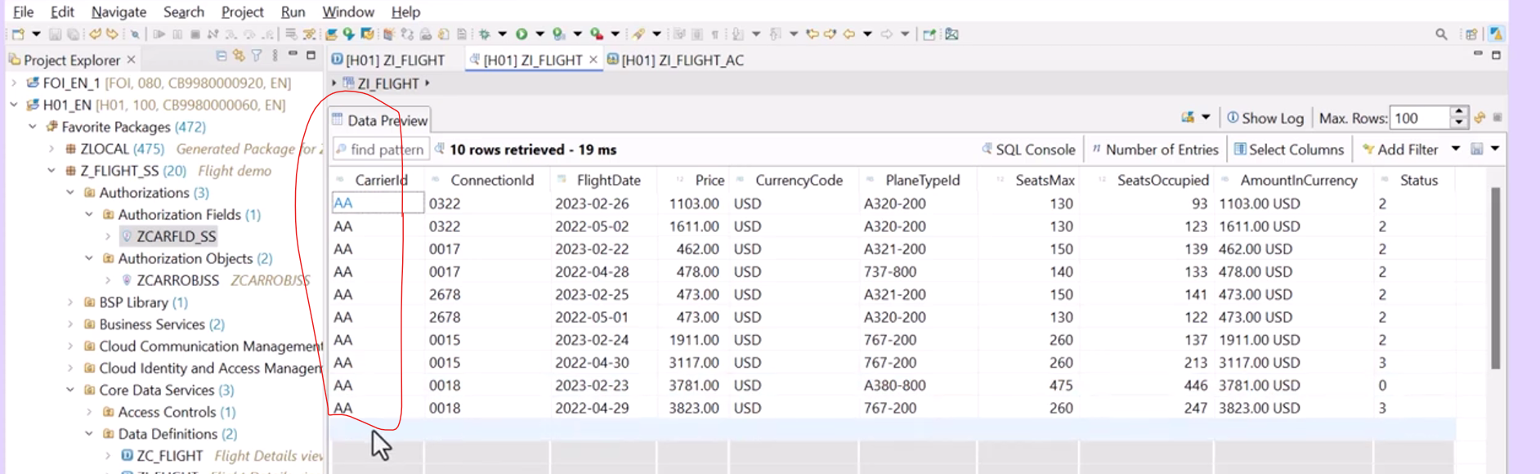
And add one more condition in access control.
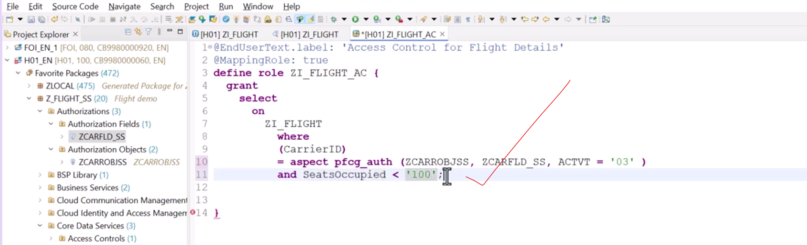
Check the data preview.
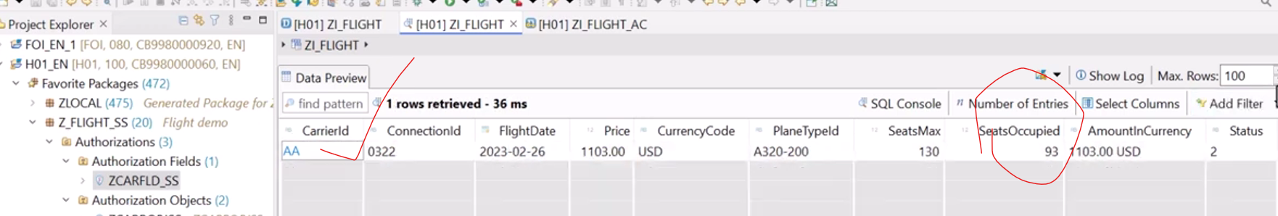

Access control for Inherit:
Inherits the access control from other aspects and apply to current entity.
ZC_FLIGHT ZI_FLIGHT ZC_FLIGHT inherits the data from ZI_FLIGHT
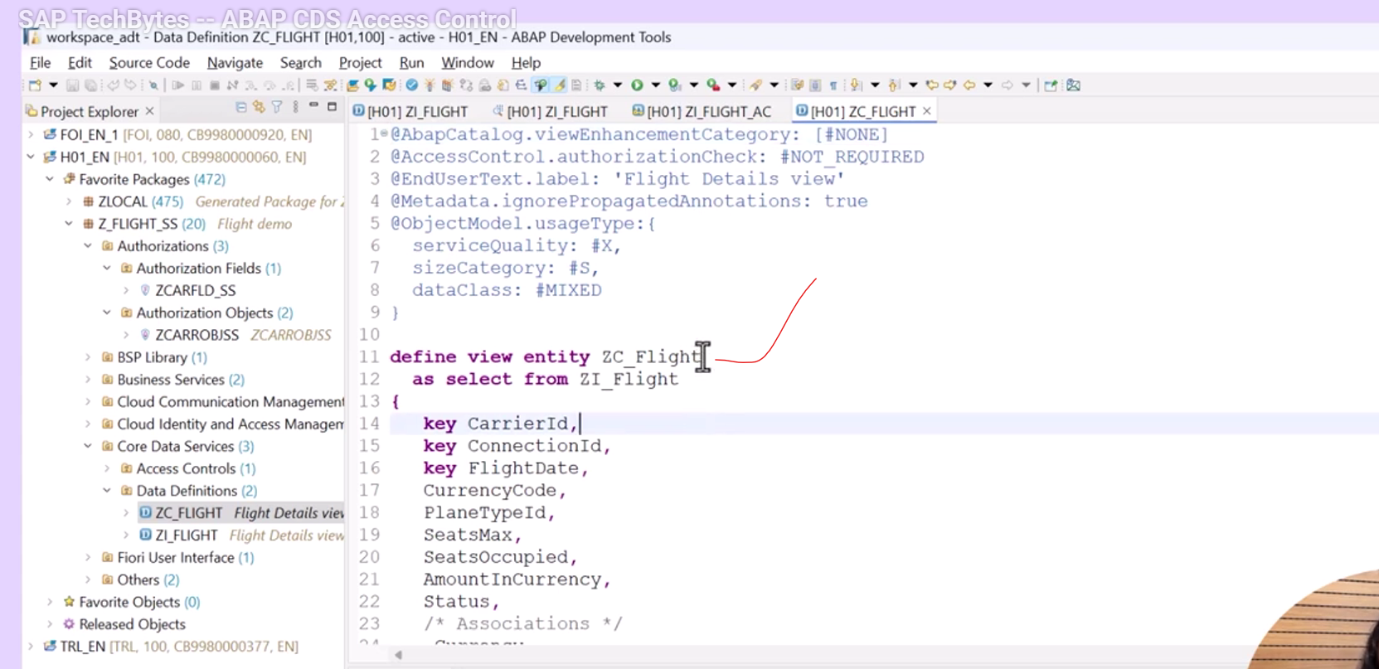
First check the preview – access controlled applied or not..
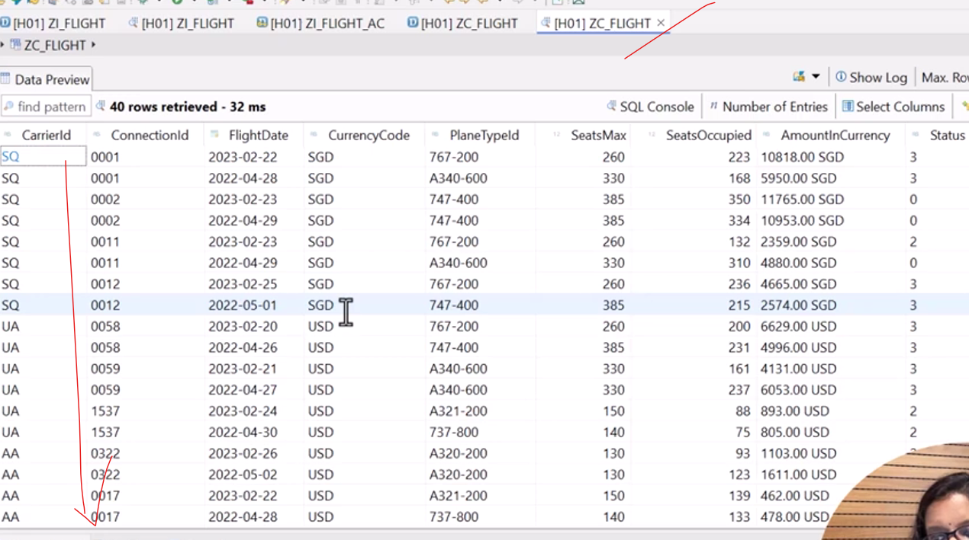
No access control applied.
Now change the authorization change value to #CHECK- now create new access control for ZC_FLIGHT
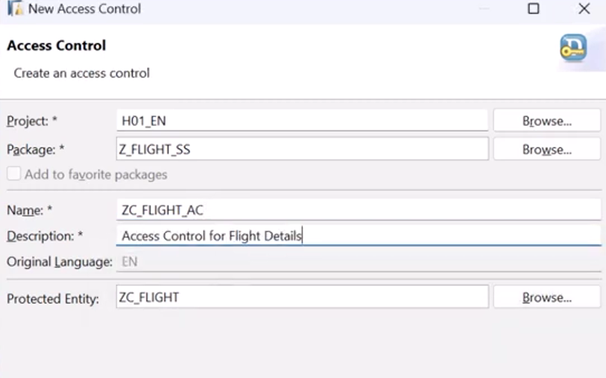
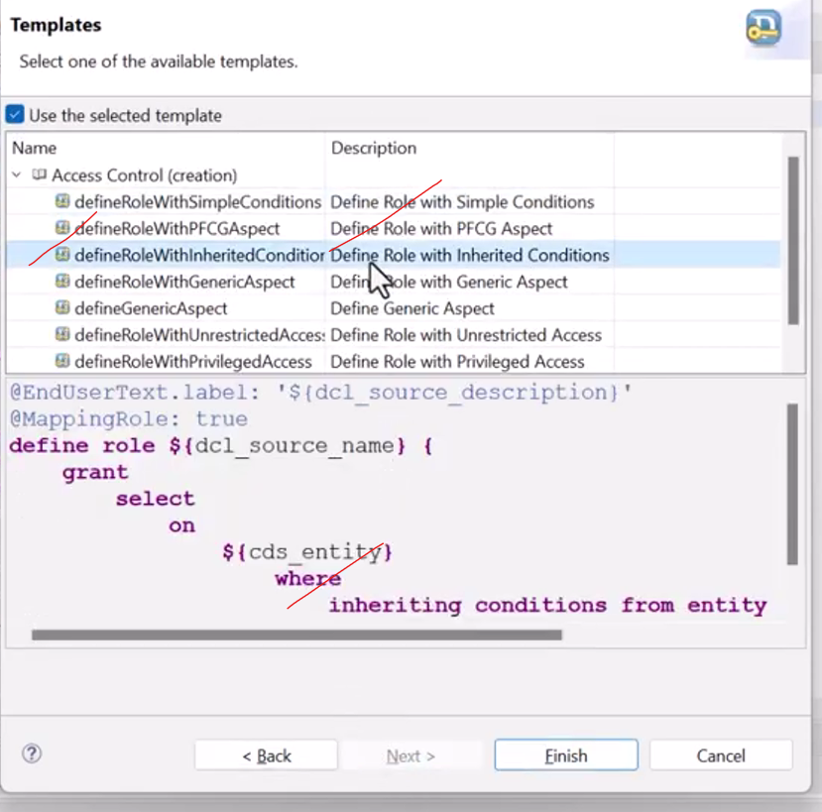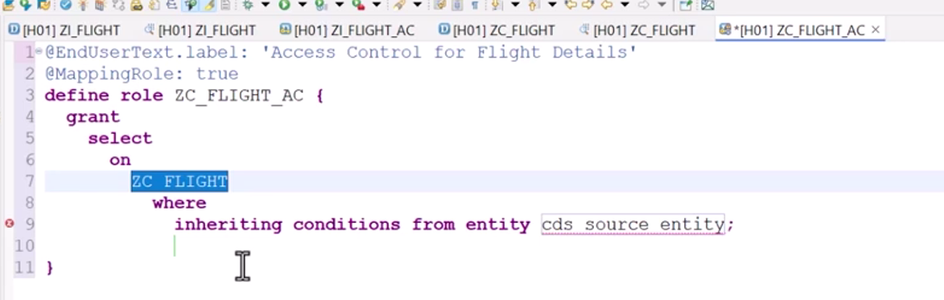


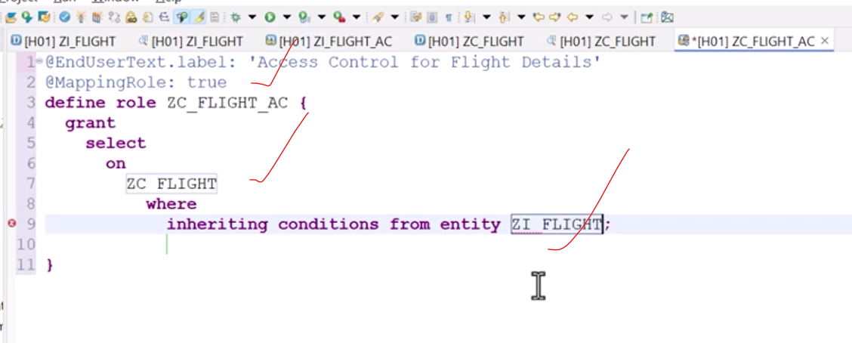
Activate and check the data preview.
Now you can see access conditions has been applied.
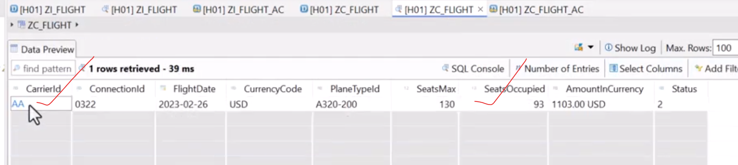

Parameter based conditions in cds access control
Add parameters to ZC_FLIGHT cds view.
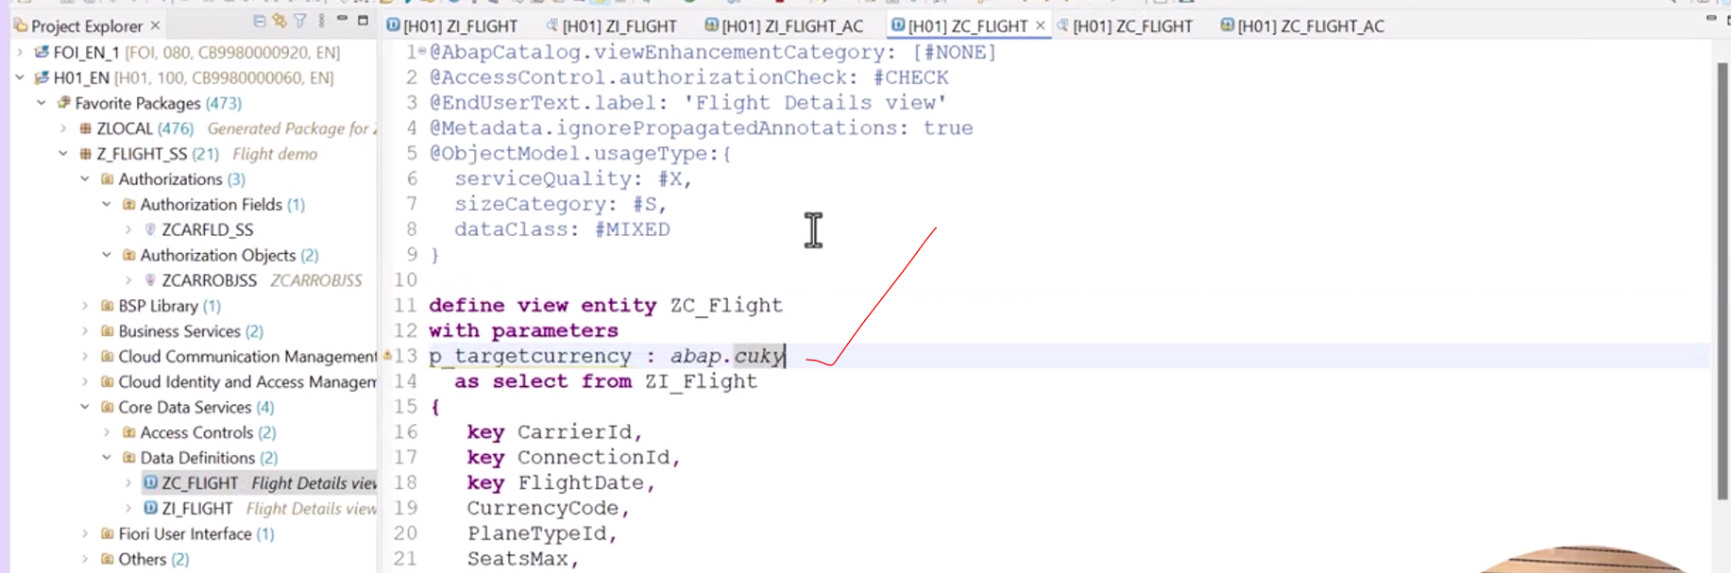
Now I want to add the parameters condition on access control and this parameters not used in the view but I have to used it in access control.
If value matches of the cds view entity and then result will come accordingly.
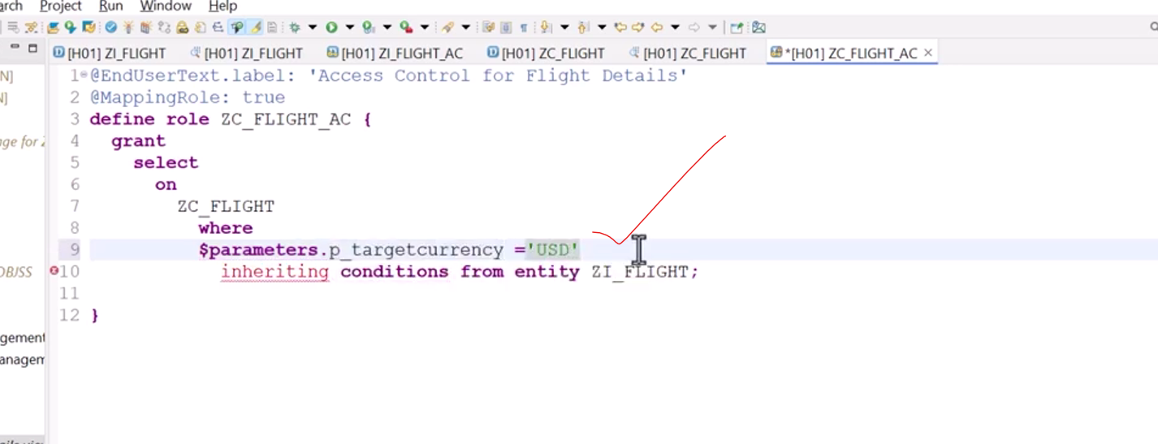
Check the data preview.
- Get the prompt to enter for currency
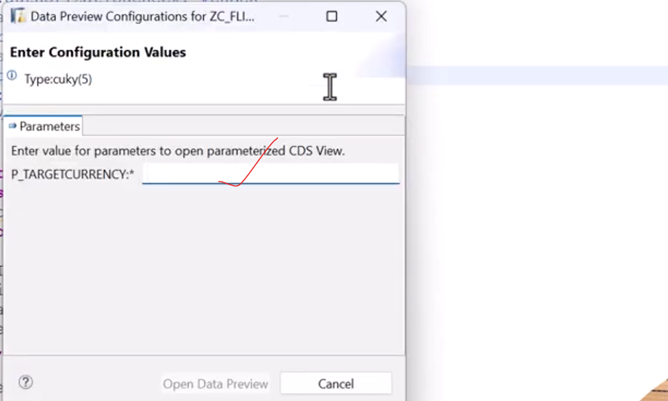
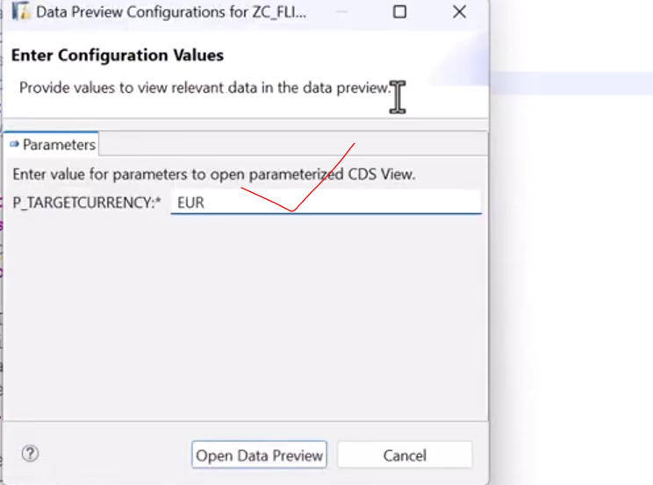
Ideally we have not received any data.. because in access control I have defined ‘USD’ but input I have given as ‘EUR’ .. so we will not get any data..
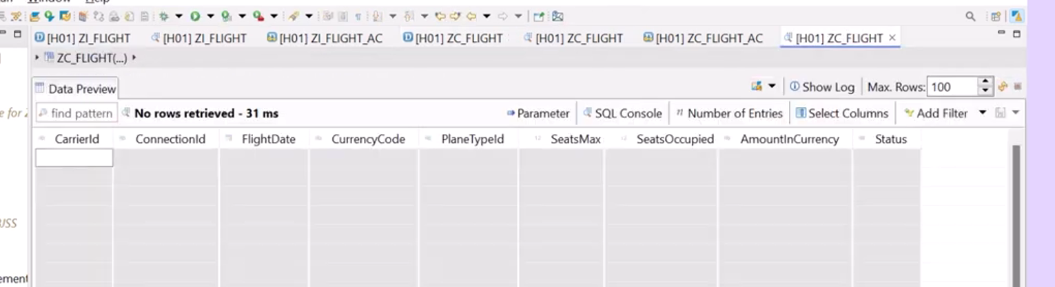

Access control where used list:
Suppose if access control available for particular cds view –(Where used list for access control of cds view) open CDS view right click on CDS view select the where used list.
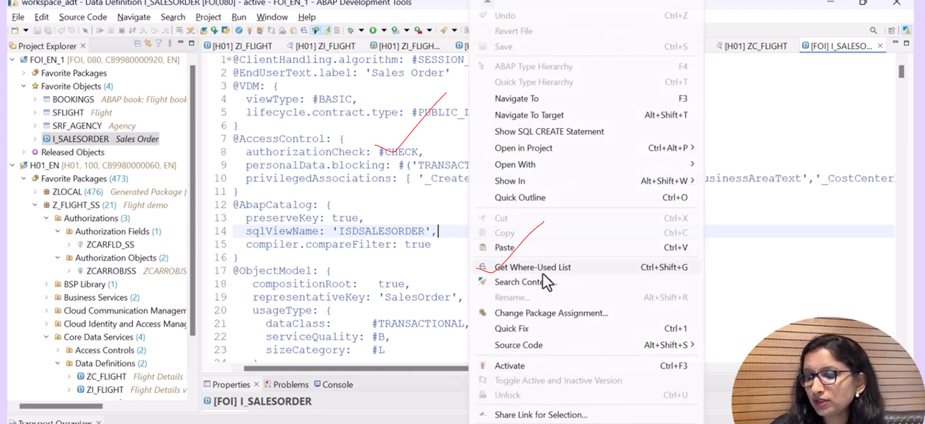
In next screen we choose the access control.
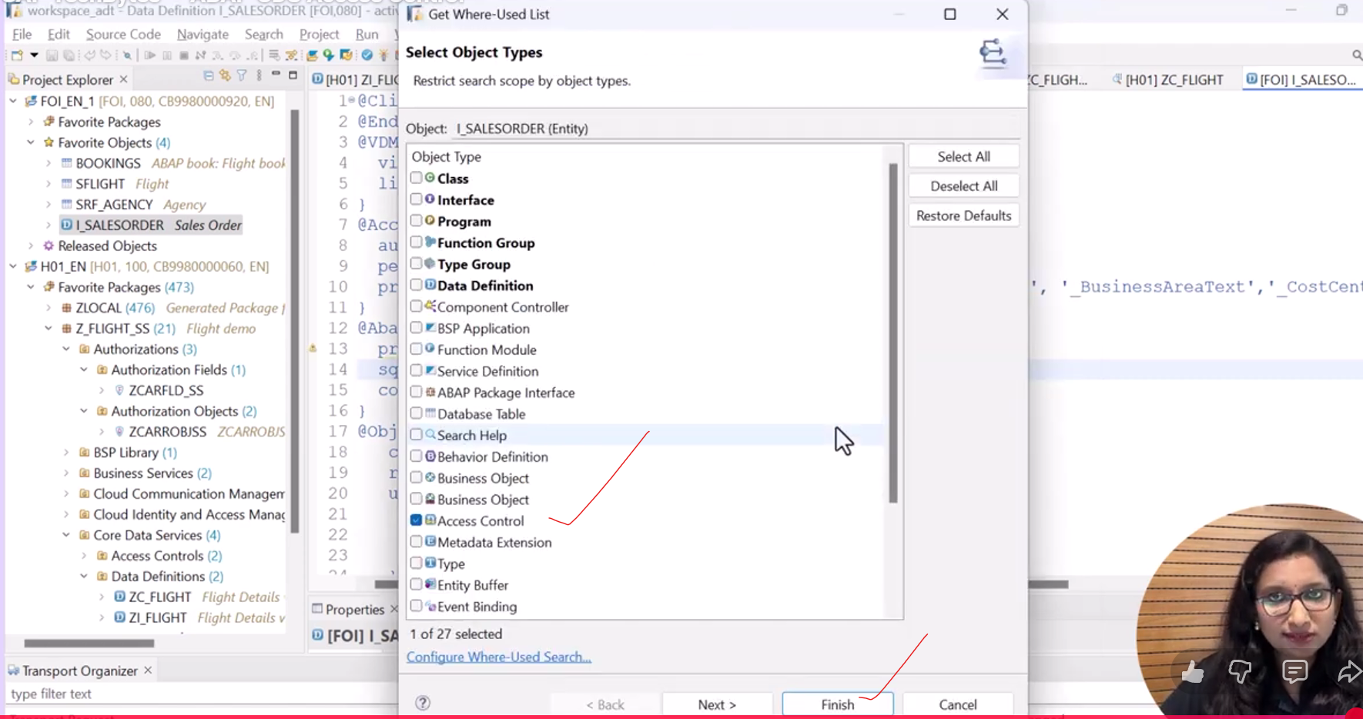
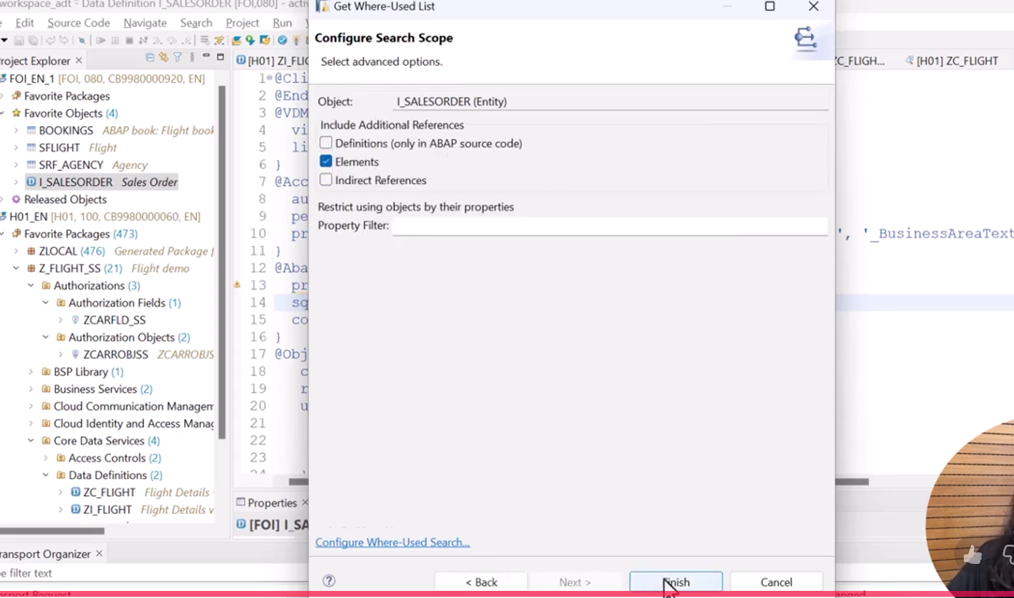
It will display all the cds views where the view is used.
